**Supplementary Requirements Release 2**

**Author:**

1. DF-In - Data Flow In

**Scope:**

* UC.01.02 Modify User Account
* UC.03.01 View/Edit Shopping Cart
* UC.03.04 Submit Order

**Requirements:**

* UC.02.06 Add products to shopping cart (wishlist) takes product data that is displayed in Browse Product(s).
* Product Name, Product Category, Product Subcategory, Price, unit data flows in for UC.02.06 Add products to shopping cart (wishlist) .
* Card Number, CVV, Card Type, EXP_Date data flows in for UC.04.01 Defining Payment Mode.

**Conditions to Apply:** After the respective join points.

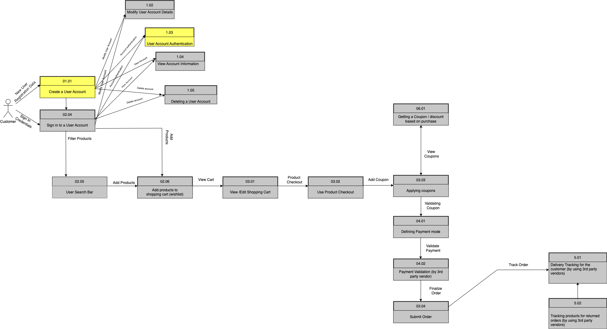

1. DF-Out - Data Flow Out

**Scope:**

* UC.01.02 Modify User Account
* UC.03.01 View/Edit Shopping Cart
* UC.03.04 Submit Order

**Requirements:**

* UC.02.06 Add products to shopping cart (wishlist) generates product data that is displayed in Browse Product(s).
* Product Name, Product Category, Product Subcategory, Price, unit data flows out for UC.02.06 Add products to shopping cart (wishlist) .

**Conditions to Apply:** After the respective join points.



3. FV - Field Validation Requirements

3.1. Field “First Name”

**Scope:**

* UC.01.02 Modify User Account

**Requirements:**

* Field should only contain letters.
* Field is mandatory; Flaunt website will not allow proceeding without a valid name format.

3.2. Field “Last Name”

**Scope:**

* UC.01.02 Modify User Account

**Requirements:**

* Field should only contain letters.
* Field is mandatory; Flaunt website will not allow proceeding without a valid name format.

**Conditions to Apply:** After the respective join points.

3.3. Field “User Name”

**Scope:**

* UC.01.02 Modify User Account

**Requirements:**

* Field should only contain combination of letters and numbers.
* Field should only be in the specified range.
* Field is mandatory; Flaunt website will not allow proceeding without a valid name format.

**Conditions to Apply:** After the respective join points.

3.4. Field “Billing City”

**Scope:**

* UC.01.02 Modify User Account

**Requirements:**

* Field should only contain letters.
* Field is mandatory, System will not allow to proceed without a valid US City.

**Conditions to Apply:** After the respective join points.

3.5. Field “Billing State”

**Scope:**

* UC.01.02 Modify User Account

**Requirements:**

* Field should only contain letters.
* Field is mandatory, System will not allow to proceed without a valid US State.

**Conditions to Apply:** After the respective join points.

3.6. Field “Billing ZIP”

**Scope:**

* UC.01.02 Modify User Account

**Requirements:**

* Field should only contain numbers.
* Field size should only contain 6 numbers.
* Field is mandatory, System will not allow to proceed without a valid US Zip Code.

**Conditions to Apply:** After the respective join points.

3.7. Field “Shipping City”

**Scope:**

* UC.01.02 Modify User Account

**Requirements:**

* Field should only contain letters.
* Field is mandatory, System will not allow to proceed without a valid US City.

**Conditions to Apply:** After the respective join points.

3.8. Field “Shipping State”

**Scope:**

* UC.01.02 Modify User Account

**Requirements:**

* Field should only contain letters.
* Field is mandatory, System will not allow to proceed without a valid US State.

**Conditions to Apply:** After the respective join points.

3.9. Field “Shipping ZIP”

**Scope:**

* UC.01.02 Modify User Account

**Requirements:**

* Field should only contain numbers.
* Field size should only contain 6 numbers.
* Field is mandatory, System will not allow to proceed without a valid US Zip Code.

**Conditions to Apply:** After the respective join points.

4. Concurrency

**Scope:**

* UC.01.02 Modify User Account
* UC.03.01 View/Edit Shopping Cart
* UC.03.04 Submit Order
* UC.06.02 View Banner Ads Homepage

**Requirements:**

* UC.01.02 Modify User Account follows the concurrency crosscut description when two users access the same Falunt Website account, it reflects the changes made to the user account on both the ends.
* UC.03.01 View/Edit Shopping Cart follows the concurrency crosscut description when two users access the cart for the same account, it reflects the changes made to the cart on both the ends.
* UC.03.04 Submit Order follows the concurrency crosscut description when two users access the same account, it reflects the changes made after submitting the order on both the ends.
* UC.06.02 View Banner Ads Homepage follows the concurrency crosscut description when two users access the same account, it reflects the same banner ads on both the ends.

**Conditions to Apply:** After the respective join points.

5. Connectivity

**Scope:**

* UC.06.02 View Banner Ads Homepage

**Requirements:**

* System should retain caches to populate values, if the front-end is disconnected due to Network issue, or some error.
* System should also show a popup window with an error message, “Connection failed, please try again later”.

**Conditions to Apply:** After the respective join points.